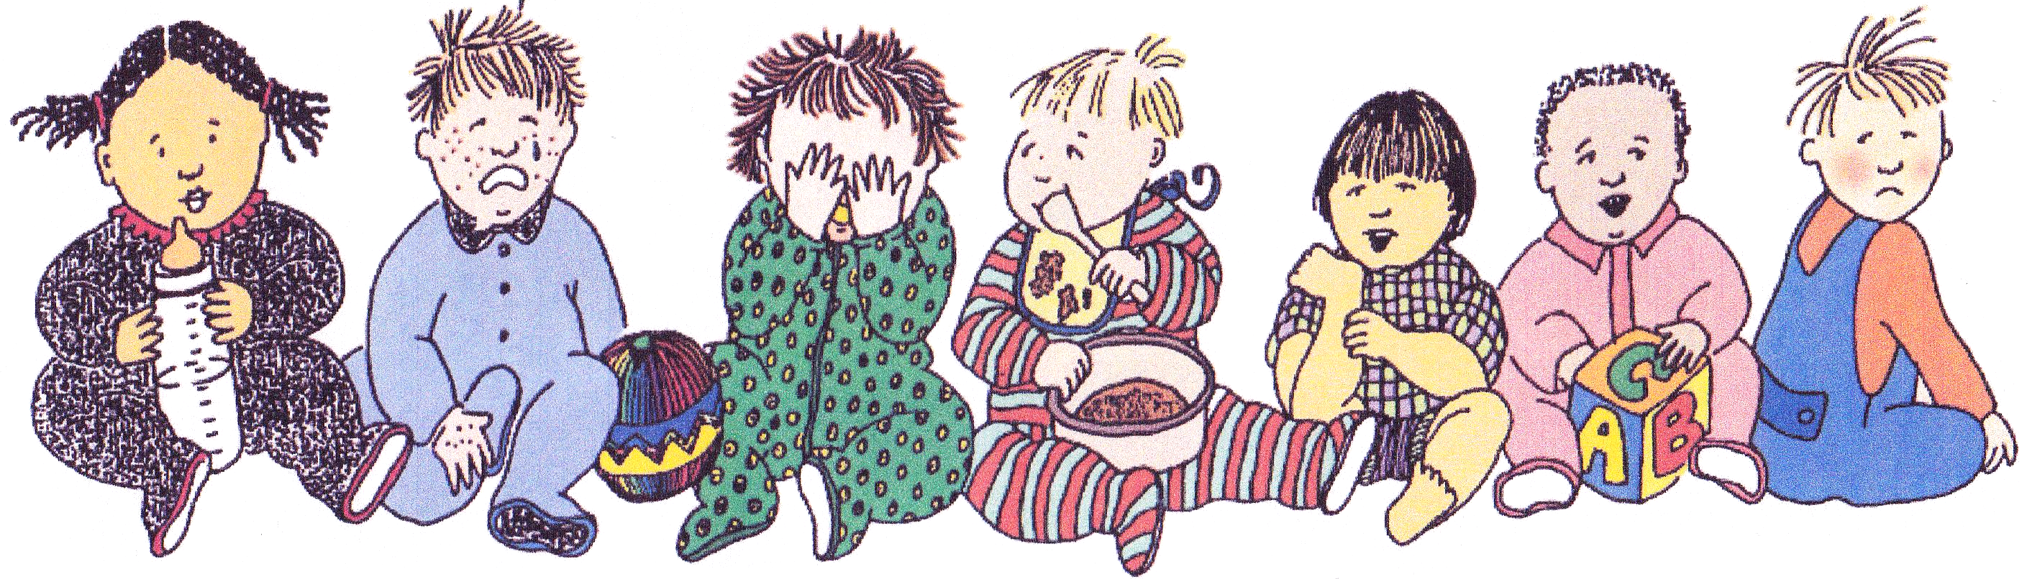Keep me home if . . .

I'm vomiting

I have a rash or skin infection

I have diarrhea

I have an eye infection

I have a bad cough or

sore throat

I'm just not feeling very good

1. Have plans for back up child care.
2. Tell your child care provider what is wrong with your child even if the child stays home.

When your child is sick:

I

have a fever

|  |  |  |  |  |  |  |
| --- | --- | --- | --- | --- | --- | --- |
| Two or more | Body rash or | More than one | Thick mucus | Cough that | Unusually | Temperature of |
| times in 24 hours. | skin infection | loose stool within | or puss | won't stop | tired, pale, | 100 degrees(F) |
|  | especially with a | 24 hours. | draining from | or sore throat | lack of | or more |
|  | fever or itching. |  | the eye. | with fever or | appetite, | (taken under the arm). |
|  |  |  |  | swollen glands. | confused |  |
|  |  |  |  |  | or cranky. |  |